**How to access your Coursepack(s) as a student**

Double check with workshop you are enrolled in:

<https://learning.monash.edu/mod/page/view.php?id=1413934>

Click on the link in the table below to access the Coursepack based on your workshop number. Make sure you click on the correct link. Otherwise, you will not be able to do the simulation with the rest of your team.

|  |  |
| --- | --- |
| Workshop | Coursepack Link |
| 1 | <https://hbsp.harvard.edu/import/1152503> |
| 2 | <https://hbsp.harvard.edu/import/1152504> |
| 3 | <https://hbsp.harvard.edu/import/1152505> |
| 4 | <https://hbsp.harvard.edu/import/1152506> |
| 5 | <https://hbsp.harvard.edu/import/1152507> |
| 6 | <https://hbsp.harvard.edu/import/1152508> |
| 7 | <https://hbsp.harvard.edu/import/1152509> |
| 8 | <https://hbsp.harvard.edu/import/1152510> |
| 9 | <https://hbsp.harvard.edu/import/1152511> |
| 10 | <https://hbsp.harvard.edu/import/1152512> |
| 11 | <https://hbsp.harvard.edu/import/1152513> |
| 12 | <https://hbsp.harvard.edu/import/1152514> |
| 13 | <https://hbsp.harvard.edu/import/1152515> |

Once you have accessed the link to your respective Harvard Business Publishing coursepack, you will navigate to this screen. If you have never registered on the site, please click on REGISTER. If you have already registered as a student when accessing a prior course on the site, please login with your login credentials by entering your **Monash student email** and password.

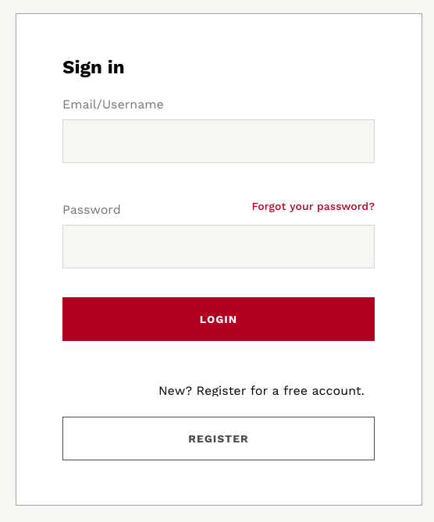 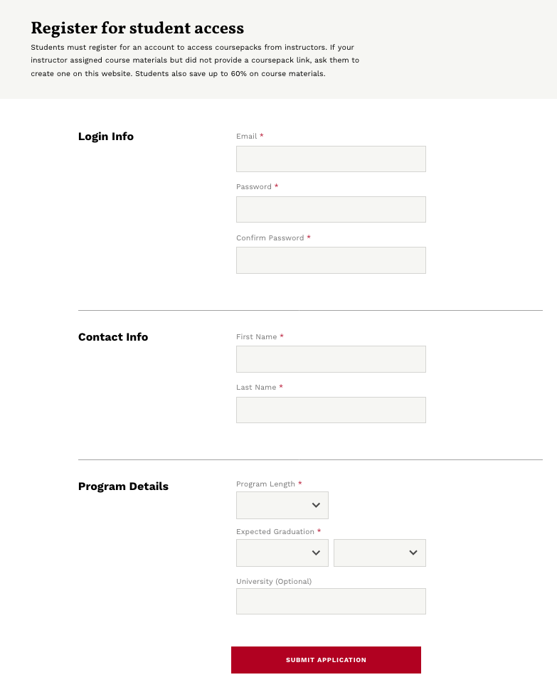

After clicking REGISTER, the screen you will navigate to in order to begin your short registration process. Please create a username & password, and fill in the other required fields

**PLEASE MAKE SURE YOU USE YOUR MONASH STUDENT EMAIL ADDRESS WHEN YOU REGISTER.** Personal email addresses (such as Google Mail, Yahoo Mail or Hotmail will not be accepted for registration).